THE EFFECT OF COOPERATIVE SCRIPT (CS) ON STUDENTS’ READING COMPREHENSION AT MTSN 2 TANJUNG JABUNG TIMUR

Desti Angraini*¹, Dwi Yunita²
¹destiangraini@uinjambi.ac.id, ³dwiyunita@gmail.com

UIN Sulthan Thaha Saifuddin Jambi

ABSTRACT
The aims of this research is to find out The Effect of Cooperative Script (CS) on Students’ Reading Comprehension at MTsN 2 Tanjung Jabung Timur. Moreover, the objective of this research is to find out significant difference between the students’ taught by Cooperative Scipt (CS) technique and those taught by teachers’ technique. This is quantitative research with quasi-experimental research design. The population and sample of this research is the students at the MTsN 2 Tanjung Jabung Timur. Which consist 22 students in experimental and 22 students in control class. The result of this research shows that there was significant effect on students’ reading comprehension after being taught through Cooperative Script (CS) technique. This could be seen from the T-test result which showed that the students mean score in experimental class 72,27 meanwhile the students mean score in control class 62,72. In the value sig. (2-tailed) was 0,002 which was lower than 0,05. The value of t0was 3,234 and df was 42. The t0 obtained is compared to t table either at 5%. At value 5% t table was 1,682. It can be analyzed that t0 is higher than t table either at level 5%. In other words, we can read 3,234>1,682. So the researcher can conclude that Ho is rejected and Ha is accepted. It means there was significant difference of reading comprehension between the students who were taught Cooperative Script (CS) technique and those who were not.

Keywords: Cooperative Script, Experimental Research, Reading Comprehension

A. INTRODUCTION
Reading comprehension is reading with the eyes of the heart. Reading related to comprehension or understanding. When people can understand the context in which they are reading, they gain information about reading. This means that understanding or something is the main goal of reading. Reading comprehension is very important for students, so English teachers should make reading learning enjoyable and fun for students. According to Umi Rizkiana (2019), comprehension is the process of acquiring meaning from related texts. It includes word (vocabulary) knowledge as well as thinking and reasoning. Therefore, comprehension is not a passive process, but an active process.

Reading is important in learning a language because it helps students understand the culture and customs of a text. During the learning process, students must be familiar with the text. Mahardinata (2012) points out that reading skills are very important, especially for students who can develop educational skills in their studies and apply them to their daily lives. Reading can provide students with information to expand their knowledge. From reading students can extract a lot information and knowledge from many text books, references and related library reading they read.

In Indonesia, English is used as a foreign language. English is one of the subjects taught at school. The Indonesian government has made English a subject in elementary to high school. Based on the curriculum K13, reading comprehension is one of the skills that must be mastered and learned in Islamic schools. In the eighth grade, students must understand the types of texts such as recount text, descriptive text, narrative text, procedure text, and etc. After reading the text, demonstrate basic understanding by answering a few questions.

Factors related to students' reading comprehension difficulties, such as vocabulary and background knowledge, grammar problems, and poor reading skills. This makes it impossible for students to obtain information by reading. According to Nurkasih (2016), "Students also found some difficulties, and students did not find it easy to acquire the ability to extract meaning and interpret information from texts" (p. 2). As a result, sometimes these subjects are boring for students and their reading comprehension scores are always poor. In addition, based on the results of research conducted by Hidayati (2018), she found that most students failed in reading comprehension because they had poor vocabulary, poor grammar mastery, had difficulty understanding long sentences and texts, and lacked comprehension. knowledge of reading comprehension strategies.

Based on preliminary observations on 15 January 2022 at MTsN 2 Tanjung Jabung Timur. The researchers found that the English teacher explained that he used the old method in teaching. Then the students got difficulties in identifying information of the text and they are not able to understand what they have read, when the students read the text they feel difficult to find out the main idea of a paragraph, general information and specific information in a text, because the students not practice their English out of the class or in their home. The students have a lack of vocabularies. In addition, they had difficulties to comprehend the text and low motivation to learn reading.

Using some strategies or techniques are the solutions to solve this problem. One of the techniques that could be used to improve the students’ reading comprehension is Cooperative Script. Cooperative Script is a technique that refers to a form of cooperative learning in pairs, in which students work in pairs and orally summarize parts of the material being studied (Suprijono, 2015). Cooperative Script learning techniques are adapted to students' abilities in the learning process and build students' ability to read and compile summaries based on the material they read, so as to improve students' conceptual understanding of the material being taught (Natalina & Srini, 2013). Through Cooperative Script learning techniques, students will be trained to develop their own ideas, thus enabling students to construct their own knowledge. In this way, students will not only focus on what is communicated by the teacher.

There are several previous research studies relevant to this topic and conducted by some researchers. The first one Marahaeni journal’s (S et al., 2018) she found that the use of Cooperative Script (CS) for teaching reading comprehension in junior high school since it has been proven to be effective in assisting students’ reading comprehension. They can share ideas with their friend in group and have a brainstrom from the cooperative script. It helps them easier in understanding the meaning of the text and what it tells about. The second, (Janggo, 2019) the researcher found that the use of Cooperative Script technique is effective to improve students’ reading comprehension on narrative text. Third, (Mahendra, 2020) the researcher found out that using Cooperative Script significantly affects the students’ reading comprehension at grade eleven SMA N 2 Pematangsiantar. The researcher found that the use of cooperative script makes students interested in the text and understand the information in the text.

Based on the explanation and the problem above, the researcher is interested in conducting a research entitled ” The Effect of Cooperative Script (CS) on Students’ Reading Comprehension at MTsN 2 Tanjung Jabung Timur

B. METHOD
The study was a quasi-experimental research, non-equivalent control group design was chosen as the desing of this study. The population of the study was eight grade students of MTsN 2 Tanjung Jabung Timur on academic year 2022/2023. In the population there are 110 students which where distributed into 5 intact classes. Researchers took samples by using purposive sampling., VIII Albukhori was assigned as experimental group and VIII Muslim as control group.

There are two variables that were used in this study namely, independent variable and dependent variable. The independent variable of this study was cooperative script technique, Meanwhile, the dependent is the student’s reading comprehension. In collecting the data, the researcher was used by reading comprehension test. According to Brown (2004), he said that the test is “a method of measuring a person’s ability, knowledge, or performance in a given domain”. The kind of test is multiple choice with consist 20 items question. The test is ready made one taken from “English Book for Junior High School” written by (Fathin, 2018). The instrument of the research will a test in the form reading paragraph in recount text that applied in pre-test and post-test.

Before the test were given to the sample, both of test were tried out 20 students at eight grade SMPN 2 Tanjung Jabung Timur. The purpose of test was obtain validity and reliability of the test. In this research there are 30 items before validity and after analyze the vailid items, there are 20 items that valid, median, mode, range, and standard deviation of the data. Inferential statistic analyze was also conducted to test the null hypothesis used in this study in investigating the effect of cooperative script on students’ reading comprehension.

C. FINDINGS AND DISCUSSION
The result of the post-test was analysed in two phases. Firstly, the data were analysed using descriptive analysis to calculate mean, standard deviation, variance, maximum score, and minimum score. Secondly, the data were analysed by using inferential analysis through t-test. The result of the analysis shows whether the difference between the mean score of two samples was significant or not. The result of the descriptive statistics of the post-test is presented in table 1.
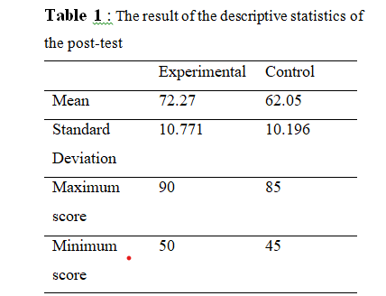
From table 1, it can be seen that mean score of experimental group was higher than control group (72.27>62.05). In term of standard of deviation, the score of 10.771 was gained by the experimental group and 10.196 was gained by the control group. From the comparison between those two groups it can be seen that the experimental group achieved higher score than the control group. Thus, it can be concluded that cooperative script technique used in experimental group gave significant effect on students’ reading comprehension.

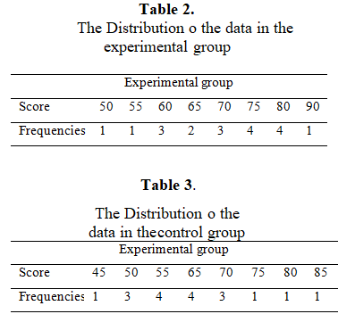
From the table 3, it can be found that the lowest score of the students in class VIII muslim was 45 achieved by 1 student. Meanwhile, the highest score was 85 achieved lowest score of the students in class VIII albukhori was 50 achieved by one student. Meanwhile, the highest score was 90 achieved by one student. Figure 2. by one student. The following chart also represented the frequency of scores in experimental group.
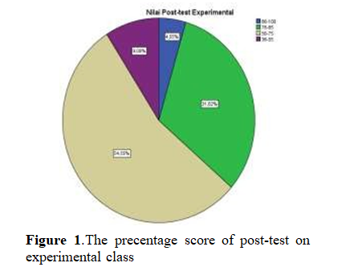
The chart above showed the precentage score of experimental group. From the chart 1, it can be seen no students cateorized very poor between (0-35). 1 students get score was good interval between (86-100) categorized very good. The precentage score of post-test on control class.
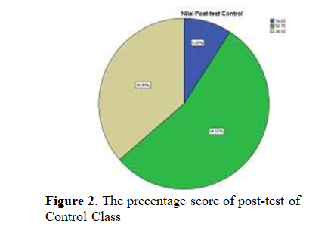
From the figure 2, it can be seen no students cateorized very poor between (0-35). 2 students get score was good interval between (76-85) categorized very good. Inferential analysis was conducted to see difference of the mean scores between the two groups taught using difference technique. In inferential statistical analysis, the data was analyzed by using t-test. Independent sample test (t-test) was used to hypothesis. The normality test and homogeneity of variance test were the requirement tests were conducted before analyzing the data inferentially by using t-test. Normality test was conducted to know whether the data of post-test for both groups were in normal distribution which exceeds significant level of 0,05 or not.

The scores of statistic value in Kolmogorov-Smirnov were ,114 with probability value Sig. (2-tailed) 0,200 for the experimental group and ,145 with probability value Sig. (2-tailed) 0,200 for control group. The result exceeded the low significant value 0,05. It means that the data were in normal distribution.

After the normality test the homogeneity of variance was also checked. The homogeneity test used Levene Statistic. Based on the results of the homogeneity test ater treatments, the probability value Sig. (2-tailed) was 0,674. The result o homogeneity test exceeded 0,05. It indicated that the variances o the data were homogeneous. , it also stated that p-value was less than 0,05 (0,000<0,05). Thus there was enough evidence indicating that the null hypothesis could be rejected, and it could be concluded that using cooperative script was effective on students’ reading comprehension while, the tcount is higher than ttable (3,234>1,678).

Based on the table the significant value 0,002 and the significant level 0,05, it means that significant level is higher than significant value. In other words, the researcher concluded that Ho is rejected and Ha is accepted

D. CONCLUSION
It aims of the research were to find out whether or not there was a significant effect and different score of eight grade students’ achievement in reading comprehension. The result showed that there was any significant effect of group who are taught by using Cooperative Script (CS) technique and those who are not. This can be seen from the result of pre-test and post-test in both groups. The mean score of pre-test in experimental class was 51,59 and the mean score of post-tes was 72,27. Meanwhile, the mean score of pre-test in control class was 53,63 and the mean score of post-test was 62,72. Both of experimental and control class learned English subject two meetings in a week and the students are asked to comprehend the recount text based on the kinds the recount in the end of each meeting.

The result of the research was stating that applying cooperative script technique in teaching learning was effective It was proved by the significant difference score of students’ reading comprehension between before and after taught by using cooperative script. So, it meant the result of the research was verived the theory by to Suprijono (2015), stated that cooperative script is helpful students’ develop reading comprehension skill. Reinserer (2001), stated that they the findings show that the students working with cooperative script is easier to understand learning draft. in this activity, repeated reading is done to avoid errors in the text.

The data on the Independent Sample Test that the mean of experimental class after taught by using Cooperative Script technique is 72,27 and mean of control class after taught without Cooperative Script technique is 62,72. The researcher used independet sample test, because to find out the differences of students mean score between the experimental class and control class. It means of statements before, the mean after taught without Cooperative Script technique is higher than after taught without Cooperative Script technique. From table 4.8 above, the mean difference between both of those group are 10,22, the differences about the lower and upper 3,846 and 16,609. So, it can be concluding that there is significance effect of taught by using Cooperative Script technique.
Based on the researcher observing, another difference of students who are taught by using Cooperative Script they were enjoy, enthuasiasm, and decrease their bored feeling in English class espicially while they are reading. Based on Krammer (2015), Cooperative Script technique can help students to be more concentrated in reading, and help students to identify important information presented in the text. It is very contrast while the researcher was observing students’ pre-test work before they got a treatment from the researcher. They look a little bit bored because they have to read most of question with a text by there is no technique and and concept. Pertiwi (2017), This cooperative script technique has an influence on student learning achievement in the cognitive aspect, namely reading achievement. And effective aspects of students' self-esteem and social competence. They also felt more enjoy in learing,because of the interactions among peers.

REFERENCES
Antoni, N. (2010). Exploring EFL teachers’ strategies in teaching reading comprehension. Penelitian Pendidikan, (11.)
Anwar. (2020). Developing students’ worksheet based educational comic for eleventh grade of vocational high school agriculture. (01).
Arikunto, S. (2010). Prosedur Penelitian Suatu Pendekatan Praktik (VIII). PT Rineka Cipta.
Brassell, D. and Rasinski, T. (2008). Comprehension That Works: Taking Students Beyond Ordinary Understanding to Deep Comprehension (pp. 1–147). http://www.shelleducation.com
Creswell, J. W. (2014). Educational research: Planning, conducting, and evaluating quantitative and qualitative research. In Educational Research (4)
Fathin, S. W. & R. E. (2018). Modul Pengayaan Bahasa Inggris Untuk SMP/MTs Kelas VIII Semester 2 (K. L. A. Agung (ed.)). CV Grahadi.
Hidayati, D. (2018). Students Difficulties In Reading Comprehension at the first grade of SMAN 1 Darussalam Aceh Besar. Ar-Rainry State Islamic University.
Isjoni, H. (2014). Cooperative Learning, Efektivitas Pembelajaran Kelompok. Bandung: Alfabeta.
Istarani, I., & Siddik, M. (2014).Model Pembelajaran Inovatif. Media Persada.
Janggo, W. O. (2019). The effectiveness of using cooperative script method to improve students’ reading comprehension on narrative text of 8thGrade Students of SMP N Kewapante, Maumere in Academic

